INFORMATION SYSTEMS PLAN
Park Games Analytics System

submitted to
Erlan Burk, Assistant Professor
IS315 – Computer Systems Analysis & Design I
Park University

submitted by
Michael Redford
Park University

March 12 2017
Table of Contents

Executive Summary iii

I. Introduction 3

II. Needs Analysis 5

III. Feasibility Analysis 6

IV. Data Analysis 7

V. Process Analysis 9

VI. Financial Analysis 10

Appendix 12

Introduction

Park games is a recently formed video game studio company who is looking to better track their sales and shipped products. Their last game shipped and sold enough to make a product but there was a huge excess of extra copies on store shelves. Park games wants to effectively ship enough products to meet demand and not have many left over copies. They also want to monitor what the reviews are for their products are and their genre, platform, etc. are.

Information System Plan

Park games wants to develop a system to track units that shipped, pre ordered, and sold and what platforms.

System Name

Park Games Inventory & Case Management System

Key System Benefits

Online inventory
Sales tracking
Preorder tracking and shipping estimates.
Easily readable data for managers.

Interrelations and interdependencies

This system will connect Park games inventory and sales process and department. Park will base inventory and shipments bases off of product sales and pre orders.

Current System

At Park games there is no effective way to manage this without order invoices that they ship to retail stores.

Replacement and Upgrades

Moving away from estimates from data and inputting the information gained from their last game to make more accurate shipments and investments will allow Park games to effectively meet demand and prevent unnecessary losses.

Needs Analysis

Park games is a recently formed video game studio company who is looking to better track their sales
and shipped products. Their last game shipped and sold enough to make a product but there was a huge
excess of extra copies on store shelves. Park games wants to effectively ship enough products to meet
demand and not have many left over copies. They also want to monitor what the reviews are for their products are and their genre, platform, etc. are.

Organizational Environment

The environment for the system will be hosted locally on the Park games’ network. This is to prevent
unauthorized users processing orders. The system will locally generate invoices for orders and store data on the local network. There will be a front end to track sales, reviews, shipped, pre ordered, and sold
and what platforms on the web but users will not be able to modify any data.
Stakeholders
This system will be developed in house to tailor it specifically for the needs of Park games. All managers
will provide input to make sure all data are features they require are included. Access will be granted to
managers and higher level management to disseminate information & control information flow.
Users
Web based users cannot modify any data on the front end. This is done locally. If someone wants more
copies to be order after seeing high pre orders for one of the games they must run this through the
management of sales and marketing before it is input into the system and an shipment is made.
Level of Management Served
When creating the system. There will be roles assigned to each account to prevent the incorrect levels
of management making the wrong decisions. You do not want the manager of code development make
a sales manager decision.
Organizational Culture
The goal with this system is to make meetings flow faster & to easily visualize definitive facts. For
example the system will able to provide actual sales, algorithmic projection of sales, & management
goals for sales to easily compare how this is going. Same with pre orders, inventory and production.
Analyst’s Organizational Interface
The analyst must track requirements and expansion goals of the system. This allows for this to be easily
improved & used across the company. Feedback is key to improving the usage and productivity across
the company.
Analyst’s Role in System Development
The analyst must make sure everything is implemented correctly and provide the interface required.
Extendibility is necessary. If new features are required or new information needs to be tracked then the
system must adapt to meet these requirements. Logistic concerns such as space, servers, operating
costs, must be reviewed.
Activities, Methodologies, Techniques to be used in System Analysis and Design
Effectively integrating the use of the system into current project management will be key to success. The
benefits of system pay off during all stages during development but key after the product is shipped. If
Park games uses the system to review similar game sales to the current product they can effectively
estimate how many copies they can sell during each game, genre, or platform.
Planned use of CASE Tools
With Visible Analyst you can see what is being developed and who is using the features.
Justification for CASE tool use
It allows us to analyze the effectiveness of the system. Are certain departments benefiting more than
others? How can those less involved in the system benefit from it?

Feasibility Analysis

System Objectives
Park Games’ system will allow the ability to make high level analytical decisions on games with data on sales, preorders, and inventory while only exposing this information to those who need to know.

Organizational Objectives
Provide information to the correct levels of management for accurate decision making based on definitive facts.

Alignment of Objectives
This system is being developed to manage sales, preorders, product reviews, and inventory.
Operational Feasibility
Park Games’ system will utilize in house technologies and servers to interact with the system. When creating the system. There will be roles assigned to each account to prevent the incorrect levels of management making the wrong decisions.
Technical Feasibility
Park games has the experts to implement this. This system will be developed in house to tailor it specifically for the needs of Park games. All managers will provide input to make sure all data are features they require are included. Web based users cannot modify any data on the front end. This is done locally. If someone wants more copies to be order after seeing high pre orders for one of the games they must run this through the management of sales and marketing before it is input into the system and an shipment is made.
Economic Feasibility
With further developing prototyped produced , licensing for the system is free since open source software was used. The system provides requests on demand & won’t have a lot of data to store as it only manages data for products released. $40,000 total development factoring in man hours used to develop the product, servers, & upkeep. Since this is an in house product staff will need to fix, add features, or maintain the software.
Recommendation
This system has a high chance at success and the initial costs of developing are not extreme. The ability to either budget better or to improve a product better is very helpful.

Data Analysis

Data Flow
The system uses data from multiple sources to work. Input is taken in from different departments. Staff will be able to input necessary components to make allow the system to work. Staff & management will be able to track multiple processes at once to get an idea of how this will be running. Reviews can be input into the system along with genre data. This will be handled with reports and invoices.
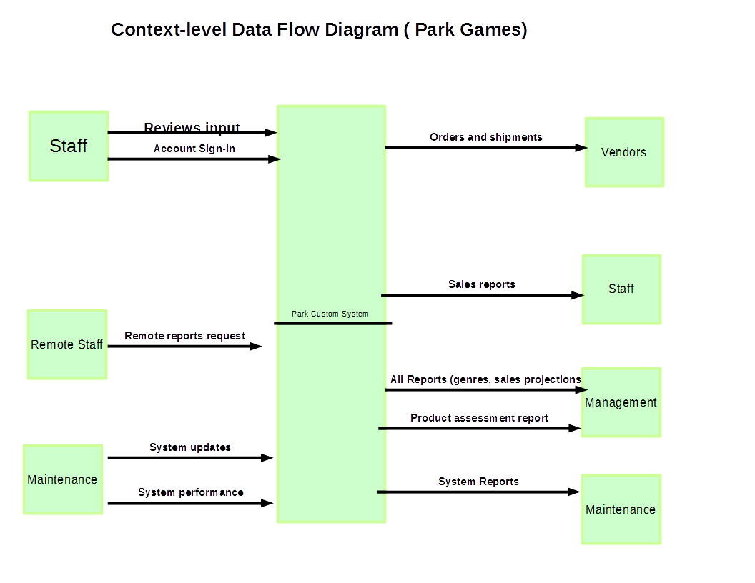
Context Level Data Flow Diagram

Elements
The staff with have an account created for them by IT. This will allow them to perform functions depending on there role. Sales can input preorder data. Advertising may only be allowed to input reviewed. All staff can view all reports but may not make changes remotely.

Data Structure
The framework for this system is being developed by scratch. There must be a vast & inclusive database that can handle multiple data types. Data structures must correctly typed and programmed efficiently to be easily expanded on for new features. A database structure seems appropriate for organizing & expanding this.
Data Storage
Parks games custom system will utilize an open source database technology such as MongoDB. The choice is simple as MongoDB allows park to easily use a CMS to visualize information and generate reports and analytic. Sections to plan for are the following:
- Accounts
- Roles
- Preorders
- Games
- Genres
- Sales
- Inventory
- Stats
- Generated case scenarios
- Generated projections for comparison
Databases will be held for all sections to effectively achieve Park Games goal.

Process Analysis

Our process have been divided down to 3 sub processes for the sake of clarity. This will clearly define what is our processes are to cover the actions of the staff, managers, and maintainers.

Order Process

Our order and inventory system is only used in house. The “customer” is the staff who requests reports, inventory status, and review inputs.

Staff Process

The staff views the reports and information generated by the system.

Management and Maintenance Process

Management requests reports to gain information on the current performance of sales inventory and reviews. Maintainers can update the system and provide management with info on the current status.

Financial Analysis

Overview

The goal of this analysis is to completely understand the cost of implementation of this server. The goal is to implement a system that must be beneficial financial for Park Games to implement. Initial installation costs are the most expensive part of the venture. Park Games will contract with a company to handle creating training to distribute to employees to learn.

Server(Install included)
$7000.00
Software
$0.00
Training & certifications
$2000.00
Domain Registration
$200.00

Server location and Installation

The server location will be in Park Games office. The needs of Park Games are small. This service is not used outside of Park Games which will keep costs on storage and expansion relatively low. This allows Park Games to invest in setting up a small scalable system but also being able to expand it if necessary. Because of the small footprint backups will be minimal and the goal is to expand the system in the future.

Server Specifications:
Dell PowerEdge M630 for M1000e
Intel® Xeon® E5-2640 v4
16GB Memory
960GB SSD Hard Drive

Operating Cost

Hosting your own servers also means that Park Games inherits the factors of server maintenance & upkeep compared to the cloud. They must consider power, parts, training personnel, and maintaining the server environment. There are no licensing cost for software as open-source technology is used used to create a full stack environment:
Ubuntu 16.04 LTS Server Edition
Open Stack ( https://www.openstack.org/ )

Open Stack certifications should be obtained ($300.00) each for current employees to ensure developers fully understand the platform: https://www.openstack.org/coa/coa-professional/

Break-Even Analysis
(How can be make up for the cost, what is going to dip profits)
Since this system has no clients out of Park Games the source of revenue for Park Games is the video game software they sell. They depend on the system to generate information to perform significantly better in the market & save Park Games from poor investments. If Park Games developed a game in a specific genre and learns from the system that the genre. What variables to take into considerations are revenue before Park Games’ Information system and after. Revenue generated by sales will be displayed over the course of a year.

Cash Flow Analysis
The initial costs of this system outweigh the value Park Games gets out of this. With this system Park Games can analyze reviews and deliver contact & direct marketing in very specific ways. In the break-even analysis we look at the previous and new revenue after utilizing the IS system. High spikes in revenue are detected after park games is generating new video game content based on information received. This sort of analysis allows park to make smart moves into other fields. This may allow expansion into fields such as advanced marketing & high-quality research.

Appendix

- Dell.com. Dell Inc. 17 July 2008. http://www.dell.com/us/business/p/poweredge-m630/pd
- Ubuntu. http://www.ubuntu.com/
- Open Stack. https://www.openstack.org/

